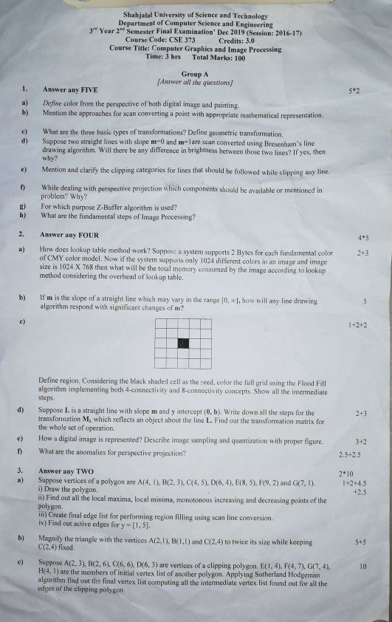
Shahjalal University of Science and Technology
Department of Computer Science and Engineering
3r Year 2" Semester Final Examination' Dec 2019 (Session: 2016-17)
^{Course Code: CSE 373} Credits: 3.0
Course Title: Computer Graphics and Image Processing
^{Time: 3 hrs} Total Marks: 100
Group A
[Answer all the questions
^{1.} Answer any FIVE _{5*2} a) Define color from the perspective of both digital image and painting.
b) ^{Mention the} approaches ^{for scan} converting ª point ^{with} appropriate ^{mathematical} representation.
What are the three basic types of transformations? Define geometric transformation.
d Suppose two straight lines with slope m=0 and m=lare scan converted using Bresenham's line drawing algorithm. Will there be any difference in brightness between those two lines? If yes, then why?
e) Mention and clarify the clipping categories for lines that should be followed while clipping any line.
While dealing with perspective projection which components should be available or mentioned in
1)
problem? Why?
For which purpose Z-Buffer algorithm is used?
What are ^{the fundamental} steps ^{of} Image Processing?
h)
Answer any FOUR _{4*5} How does lookup table method work? Suppose a system supports 2 Bytes for each fundamental color
^{a)} 2+3 of CMY color model. Now if ^{the} system supports only ^{1024 different eolors in an} image ^{and image} size is 1024 X 768 then what will be the ^{total} _{memory} consumed _{by} ^{the} image according ^{to} lookup method considering the overhead of lookup table.
If m ^{is the} slope ^{of a} straight ^{line which} may vary ^{in the} range [0, co], ^{how will} _{any} ^{line drawing} algorithm respond with significant changes of m'? b)
^{C)} 1+2+2
Define region. Considering the black shaded cell as the seed, color the full grid using the Flood Fill algorithm implementing both 4-connectivity and 8-connectivity concepts. Show all the intermediate steps.
Suppose L is a straight line with slope m and y intercept (0, b). Write down all the steps for the ^{d)} 2+3 transformation M which reflects an object about the line L. Find out the transformation matrix for the whole set ^{of} operation.
e) ^{How a} digital image ^{is} represented? ^{Describe} image sampling ^{and} quantization ^{with} proper figure. 3+2 What are the anomalies ^{for} perspective projection? 2.5+2.5
3. Answer any TWO _{2*10}
a) Suppose vertices of a polygon are A(4, 1), B(2, 3), C4, 5), D(6, 4), E(8, 5), F9, 2) and G(7, 1). i) Draw the polygon.
11) Find out all the local maxima, local minima, monotonous increasing and decreasing points ot the polygon.
1i) Create ^{final} edge ^{list for} performing region filling using ^{scan line conversion.} iv) Find out ^{active} edges ^{for} y ⁼ [1, 5].
1+2+4.5 +2.5
b) Magnify the triangle with the vertices A(2,1), B(1,1) and C(2,4) to twice its size while keeping ₊₅ C(2,4) fixed.
c) Suppose A(2, 3), B(2, 6), C(6, 6), D(6, 3) are vertices ofa clipping polygon. E(1, 4), F(4, 7), G(7, 4),
10
H(4, ) are the ^{members of} initial vertex list of ^{another} polygon. Applying ^{Sutherland} Hodgeman algorithm find out the final vertex list computing all the intermediate vertex list found out for all the edges of the clipping polygon.
Group B
Answer all the questions _{5*2 Answer any FIVE} What are the fundamental colors of CMY color model? Write down the cquation for converting the CMY
model into the RGB model.
Suppose P(x. y) is a point of an object A. Derive the equation with an appropriate figure for translating it to b)
the point P'(x'. y) according to the direction vector v ^{=t,i+} t,j using geometric ^{translation.}
What is vanishing point?
d If an M x N sized digital display supports 2 different colors then calculate the given issues i) Nuniber of pixel in the display
ii) Memory necessary for each supporting color
ii) Total memory required for the display to present an image
iv) Aspect ratio of the display.
Derive the general form of an oblique projection onto the xy plane.
)
Differentiate between boundary-fill and flood-fill algorithm.
) While scan converting a circle if we try with both trigonometric approach and Bresenham's circle algorithm will the eight-point symmetry concept give any advantage to one of them over another? Briefly explain. In every 2D rotation we actually perform a 3D rotation."- Is the statement right? Justify your answer. _{h)}
Answer any FOUR
Demonstrate how will you determine whether a point P(x.y) lies to the left or to the right of a line segment
a)
joining the points A(x1,.y) and B(x2,y 2).
b) The endpoints of a given line are (0, 0) to (5, 8). Indicate which raster locations would be chosen by Bresenham's algorithm.
Suppose A(2, 3, 5) and B(8, 12, 20) are two points of a straight line.
^{c)} 342
i) Write down the parametric equation of the line.
ii) Among C(4, 6. 10), D10, i5., 25). E(i.5, 10), F(6, 10, 15) which points are also in the same line with A and B?
Supposea 5x5(0 indexed)display is given with initial Z values for cach of the cell,
d)
2,2. 1). 2, 4, 3). (0, 0, 3).
(4,2, 4). (4, 4, 7). (4, 4, 1),
(2. 4, 6). (3, 1. 7). (0. 4, 5).
0
₉ (2,0, 5)
2.107 ⁹
Find out the final display matrix with minimum possible Z value for each cell plotting all the points from the given pool. ^{Make a list of} points ^{that will be} ignored ^{because of} the ir ^{Z values.}
How does Sutherland-Hodgeman algorithm work? Discuss in brief. e) ⁵
^{Define canonical} 1+2+2 rotation. Define tilting as a rotation about the x-axis followed by y-axis: (a) find the tilting matrix (b) does the order of performing the rotation matter?
6. Answer any TWO
_{a)} The pyramid defined by the coordinates A(0, 0, 0), B(1, 0, 0), CO, 1, 0) and D(0, 0, 1) is rotated 45 about the 10 ine L that has the direction V J+K and passing through point C(0, 1, 0). Find out the coordinates of the rotated pyramid.
Let R be the rectangular window whose lower left-hand corner is at L(-3,1) and upper right-hand corner is at 4+2+4
b)
R(2,6). Find the region codes and clipping category for the following lines using Cohen-Sutherland algorithm: AB (4,2).(-1,7) CD = (-1.5).(3,8) EF = (-2,3).(1,2) GH = (1,-2),3,3)
and J=(4,7).(-2,10)
Using the origin as the center of projection, derive the perspective transformation onto the plane passing
c) 10 through the point R(Xo, Yo, Zo) and having the normal vector N = n,I + nd + n;K.
Page 2/ 2

